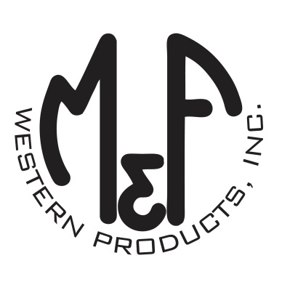

PRODUCT DESCRIPTION

**#B03976**

**Details**

* Boot Doctor Leathercare
* Boot Care Travel Kit
* 2 oz. Bottle Cleaner 1 Leather Cleaner
* 2 oz. Bottle Formula 4 Conditioner
* One Boot Shine Cloth
* Packaged in a Reusable Vinyl Carrying Case with Handle
* Made in the USA

**Description**Premium quality leather care from Boot Doctor, by M&F Western Products. Contains 1 bottle of Cleaner 1 Leather Cleaner - aggressively cleans all smooth, finished leather, and 1 bottle of Formula 4 Conditioner specially formulated to clean, condition, polish and protect. This kit also includes a cleaning cloth and packaged neatly in a reusable vinyl carrying case to keep everything neat and together.   
  
**Application Instructions:** Before use, see product description for more details on how to apply.