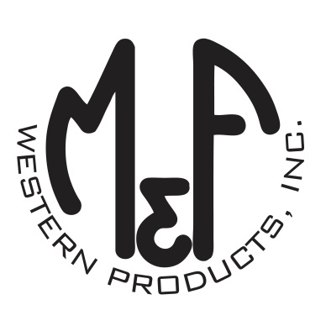

PRODUCT DESCRIPTION

**#A300006201**

**Details**

* Ariat Mens Cap
* Black and Grey
* One Size: Adjustable Snap Closure
* 6 Panels
* Fit: Richardson 112
* Round Oil Derrick Patch
* White Mesh Back
* Embroidered Eyelets
* Matching Fabric Button Sewn on Top
* 65% Polyester, 35% Cotton
* 7 Post Snap Closure

**Description**  
  
*You will reach for this fashionable and comfortable Ariat cap by M&F Western Products each time you go out. There is a round patch on the front that has an oil derrick in the center and Ariat Co. on the top. The front of the cap is black with a grey bill and white contrast stitching. A white mesh back with snap adjustments means you will get a perfect fit. You will love the all day comfort of this great cap.*

