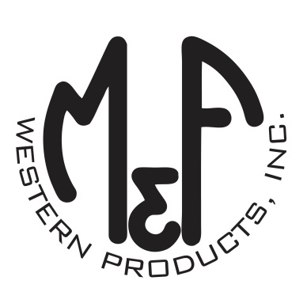

PRODUCT DESCRIPTION

**#A300004708**

**Details**

* Ariat Mens Cap
* Tan
* One Size: Flexfit 110 Comfort Fit Technology
* 6 Panels
* Fit: Low Profile
* Leather Ariat Signature Logo Patch
* Embroidered Eyelets
* Matching Fabric Button Sewn on Top
* Brass Clip Fabric Closure

**Description**  
  
*You will reach for this fashionable and comfortable Ariat cap by M&F Western Products each time you go out. There is a leather Ariat Signature Logo on the front of the tan crown. Cap fastens in the back with a brass clip.*

