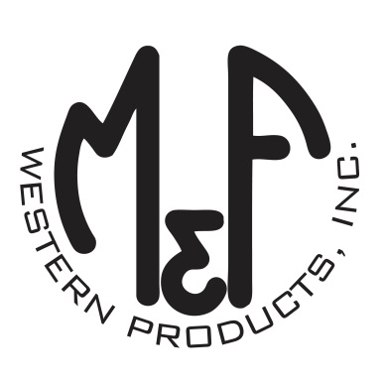

PRODUCT DESCRIPTION

**#A300004406**

**Details**

* Ariat Mens Cap
* Grey
* One Size: Adjustable Snap Closure
* 6 Panels
* Ariat Signature Logo Patch with Sunset
* Grey Mesh Back
* Embroidered Eyelets
* Matching Fabric Button Sewn on Top
* 7 Post Snap Closure
* 97% Polyester 3% Elastane

**Description**  
  
*You will reach for this fashionable and comfortable Ariat cap by M&F Western Products each time you go out. There is a thick blue and black sunset image patch with an Ariat Signature Logo on the front and a grey mesh back with a snap closure so you will get a perfect fit. You will love this great cap.*

