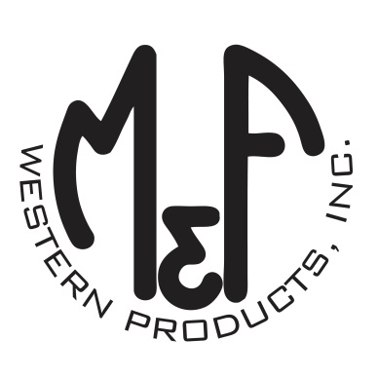

PRODUCT DESCRIPTION

**#A300004203**

**Details**

* Ariat Mens Cap
* Red, White and Blue
* One Size: Adjustable Snap Closure
* 6 Panels
* Rubber Ariat Signature Logo Centered on Front
* White Mesh Back
* Flag Patch
* Embroidered Eyelets
* Matching Fabric Button Sewn on Top
* 7 Post Snap Closure
* 96% Polyester 4% Spandex

**Description**  
  
*You will reach for this patriotic and comfortable Ariat cap by M&F Western Products each time you go out. There is a centered rubber Ariat Signature Logo and USA flag on the front of the cap, and a white mesh back with snap adjustments so you will get a perfect fit. You will love this great cap.*

