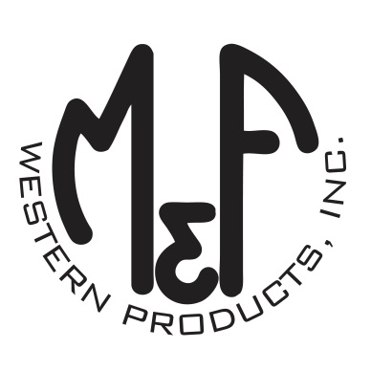

PRODUCT DESCRIPTION

**#A300003708**

**Details**

* Ariat Mens Cap
* Tan, Grey and Brown
* One Size: Adjustable Snap Closure
* 6 Panels
* Fit: Low Profile, Unstructured
* Ariat Signature Logo on Front
* Aztec Design
* Brown Mesh Back
* Embroidered Eyelets
* Matching Fabric Button Sewn on Top
* 7 Post Snap Closure
* 100% Polyester Woven

**Description**  
  
*You will reach for this fashionable and comfortable Ariat cap by M&F Western Products each time you go out. There is an Ariat Signature Logo embroidered on the front of the Aztec print cap and a nylon mesh back with snap adjustments so you will get a perfect fit. You will love wearing this great cap.*

