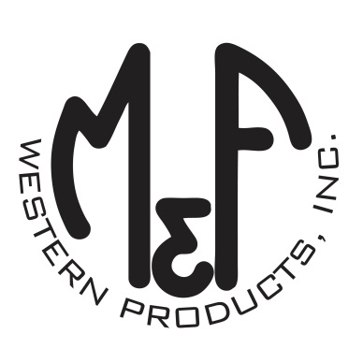

PRODUCT DESCRIPTION

**#A3000029146**

**Details**

* Ariat Mens Cap
* Khaki Heather
* One Size: Flexfit 110 Comfort Fit Technology
* 6 Panel
* Medium High Profile, Structured
* Ariat Signature Logo on Front
* Brown Upper Edge Piping
* White Mesh Snap Back
* Embroidered Eyelets
* Matching Fabric Button Sewn on Top
* 7 Post Snap Closure
* 63% Polyester 30% Acrylic 4% Wool 3% PU

**Description**  
  
*Step out with your friends in this fashionable Ariat Flexfit cap by M&F Western Products. The unique Flexfit 110 technology keeps a snug, comfortable fit while allowing the flexibility of adjustment with a snap back.* *You will reach for this great cap every time you go out.*

