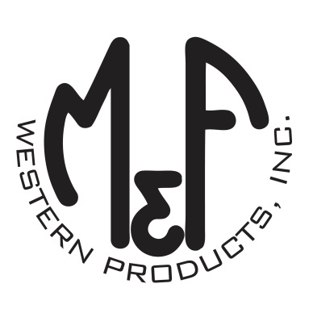

PRODUCT DESCRIPTION

**#A300002707**

**Details**

* Ariat Mens Cap
* Charcoal
* One Size: Adjustable Snap Closure
* 6 Panels
* Ariat Signature Logo Patch on Front
* Large Centered Blue and White Striped Buffalo
* Fabric Snap Back
* Embroidered Eyelets
* Lime Contrast Stitching
* Matching Fabric Button Sewn on Top
* 7 Post Snap Closure
* 100% Cotton Woven

**Description**  
  
*You will reach for this fashionable and comfortable Ariat cap by M&F Western Products each time you go out. There is a large blue and white striped buffalo and an Ariat Signature Logo patch on the front of the charcoal crown. A fabric back with snap adjustments will get you a perfect fit. You will love to wear this great cap.*

