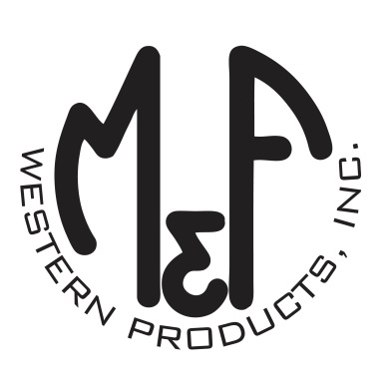

PRODUCT DESCRIPTION

**#A300002601**

**Details**

* Ariat Mens Cap
* Black Heather
* Sizes: S/M and L/XL Flex fit Technology
* 6 Panel
* Medium High Profile, Structured
* Ariat Signature Logo Patch on Front
* Black Mesh Back
* Embroidered Eyelets
* Matching Fabric Button Sewn on Top
* 97% Polyester 3% PU

**Description**  
  
*Geared for the active lifestyle, this Ariat Flex fit cap by M&F Western Products is a high-quality blend of materials designed to fit comfortably on your head. The Flex fit sizing keeps a snug, comfortable fit.* *This popular cap looks great on anyone.*

