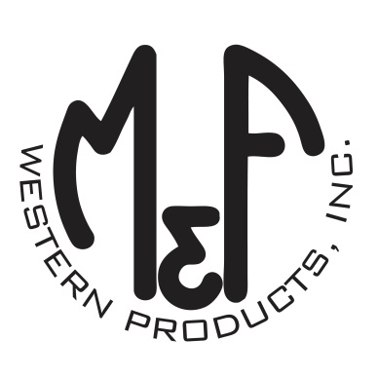

PRODUCT DESCRIPTION

**#A300002303**

**Details**

* Ariat Mens Cap
* Grey
* One Size: Flexfit 110 Comfort Fit Technology
* 6 Panels
* Fit: Medium High Profile, Structured
* Embroidered Ariat Signature Logo
* Heathered Look
* Navy Piping
* Embroidered Eyelets
* Matching Fabric Button Sewn on Top
* 7 Post Snap Closure
* 87% Acrylic 11% Wool 2% PU

**Description**  
  
*Step out with your friends in this fashionable Ariat Flexfit cap by M&F Western Products. The unique Flexfit 110 technology keeps a snug, comfortable fit while allowing the flexibility of adjustment with a snap back.* *You will reach for this great cap every time you go out.*

