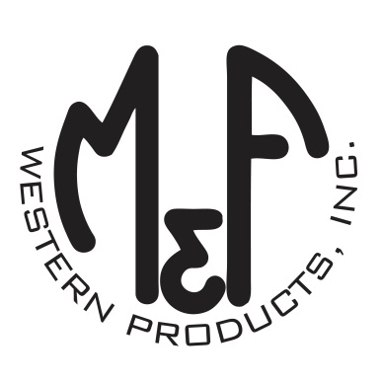

PRODUCT DESCRIPTION

**#A300002006**

**Details**

* Ariat Mens Cap
* Grey/Black
* One Size: Adjustable Snap Closure
* Unstructured
* 6 Panels
* Ariat Signature Logo Patch on Front
* Grey Fabric in Back
* Embroidered Eyelets
* Matching Fabric Button Sewn on Top
* 7 Post Snap Closure

**Description**  
  
*You will reach for this fashionable and comfortable Ariat cap by M&F Western Products each time you go out. There is a white and black Ariat Signature Logo patch centered on the front of the grey crown, and a grey fabric back completes this great looking cap. Back snap adjustments so you will get a perfect fit.*

