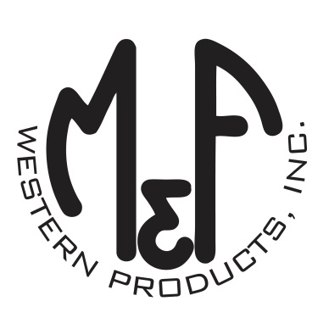

PRODUCT DESCRIPTION

**#A300001920**

**Details**

* Ariat Mens Cap
* Denim Blue
* One Size: Adjustable Snap Closure
* 6 Panels
* Denim Front and Bill
* Ariat Signature Logo Patch on Front
* White Mesh Back
* Contrast Stitching
* Embroidered Eyelets
* Matching Fabric Button Sewn on Top
* 7 Post Snap Closure
* 60% Polyester 40% Cotton

**Description**  
  
*You will reach for this fashionable and comfortable Ariat cap by M&F Western Products each time you go out. There is a red and black Ariat Signature Logo patch centered on the front of the denim crown, and a white mesh back completes this great looking cap. Back snap adjustments so you will get a perfect fit.*

