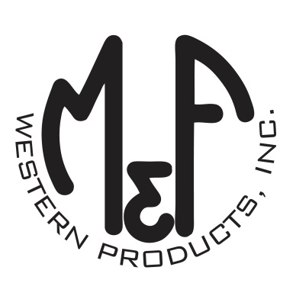

PRODUCT DESCRIPTION

**#A3000018146**

**Details**

* Ariat Mens Cap
* Khaki
* One Size: Adjustable Snap Closure
* 6 Panels
* Corduroy Front and Bill
* Ariat Signature Logo Patch Centered on Front
* Grey Mesh Back
* Matching Fabric Button Sewn on Top
* 7 Post Snap Closure

**Description**  
  
*You will reach for this fashionable and comfortable Ariat cap by M&F Western Products each time you go out. There is a centered Ariat Signature Logo patch on the front of the khaki corduroy crown, and a grey mesh back completes this great looking cap. Back snap adjustments so you will get a perfect fit.*

