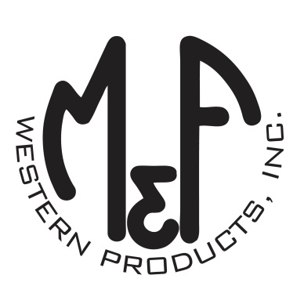

PRODUCT DESCRIPTION

**#A300001628**

**Details**

* Ariat Mens Cap
* Olive Green
* One Size: Flexfit 110 Comfort Fit Technology
* 6 Panel Flexfit Technology
* Medium High Profile, Structured
* Ariat Signature Logo on Front and Back
* Grey Mesh Back
* Holographic Flexfit 110 Brim Sticker
* Matching Fabric Button Sewn on Top
* 7 Post Snap Closure
* 60 % Polyester 40% Cotton

**Description**  
  
*Step out with your friends in this fashionable Ariat Flexfit cap by M&F Western Products. The unique Flexfit 110 technology keeps a snug, comfortable fit while allowing the flexibility of adjustment with a snap back.* *You will reach for this great cap every time you go out.*

