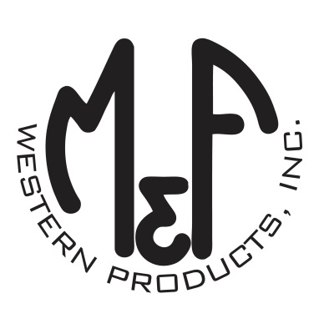

PRODUCT DESCRIPTION

**#A300001502**

**Details**

* Ariat Mens Cap
* Brown and Grey
* Sizes: S/M (6-3/4″ to 7-1/4″), L/XL (7-1/8″ to 7-5/8”)
* 6 Panels
* Medium High Profile, Structured
* Ariat Signature Logo Patch in Black, Red and White
* Herringbone Pattern
* Brown Mesh Back
* Embroidered Eyelets for Ventilation
* Matching Fabric Button Sewn on Top
* 7 Post Snap Closure
* 50% Polyester 47% Rayon 3% PU

**Description**  
  
*Keep the sun out of your eyes in style with this mens Ariat cap by M&F Western Products. This cap has a brown herringbone pattern on the crown and a grey herringbone pattern on the bill. There is a black, red and white Ariat Signature Logo patch on the front. The cap comes in 2 sizes so you will get that perfect fit. You will reach for this good looking and functional cap every time you leave the house.*