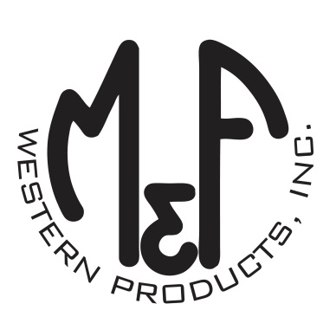

PRODUCT DESCRIPTION

**#A300001306**

**Details**

* Ariat Mens Cap
* Grey
* Sizes: S/M (6-3/4” to 7-1/4”), L/XL (7-1/8” to 7-5/8”)
* 6 Panels
* Medium High Profile, Structured
* Ariat Signature Logo in Navy and Grey
* Grey Fabric In Back
* Embroidered Eyelets for Ventilation
* Matching Fabric Button Sewn on Top
* 7 Post Snap Closure

**Description**  
  
*Keep the wind and sun at bay with this Ariat cap by M&F Western Products. This grey cap is all fabric and has a navy and grey distressed Ariat Signature Logo on the front. This great looking cap comes in 2 sizes so that you will be sure to get a perfect fit. You will reach for this quality cap every time you leave the house.*