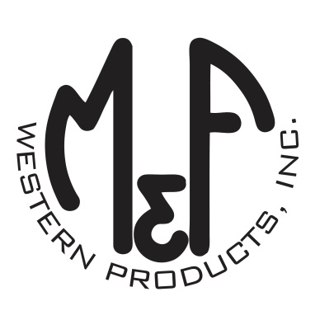

PRODUCT DESCRIPTION

**#A300000402**

**Details**

* Ariat Mens Cap
* Brown
* One Size: Adjustable Snap Closure
* 6 Panels
* Medium High Profile, Structured
* Ariat Signature Logo on Faux Leather Patch
* Rubber USA Flag
* Camo Fabric on Back and Under the Bill
* Embroidered Eyelets for Ventilation
* Matching Fabric Button Sewn on Top
* 7 Post Snap Closure

**Description**  
  
*Show your country style with this Ariat cap by M&F Western Products. The cap has a brown oilskin front with a camo back. There is a faux leather patch with an Ariat signature logo on the front. The cap has a 7 post snap closure to get that perfect fit. You will reach for this good looking and functional cap every time you leave the house.*