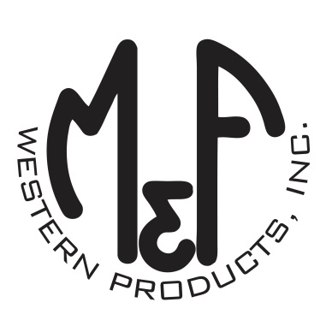

PRODUCT DESCRIPTION

**#A300000006**

**Details**

* Ariat Ladies Cap
* Grey
* One Size: Adjustable Snap Closure
* 6 Panels
* Unstructured Crown
* Ariat Signature Logo on Faux Brown Leather
* Multi Colored Arrows on Top and Under Bill
* Contrast Stitching
* Embroidered Eyelets for Ventilation
* Matching Fabric Button Sewn on Top
* 7 Post Snap Closure

**Description**  
  
*Go to town in western fashion with this Ariat cap by M&F Western Products. The cap is grey with a white bill that has multi colored arrows on the top and underneath. There is a embossed Signature Ariat Logo on faux leather on the front of the cap. The back 7 post snap closure to get that perfect fit. You will love the quality and comfort of this beautiful cap.*

