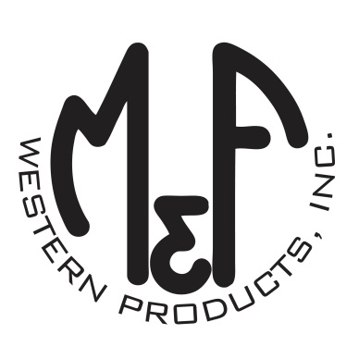

PRODUCT DESCRIPTION

**#A1800344**

**Details**

* Ariat Leather Knife Sheath
* Medium Brown
* Exterior Measurements: 4” x 2-1/4”
* Opening: 1-1/2” x 1/2”
* Soft Leather Sheath
* Black Embossed Ariat Signature Logo
* Double Contrast Stitching
* Loop For Belt For Secure Fastening
* Fits Up to a 1-1/2” Belt

**Description**  
  
*Carry your favorite knife with you every day with this Ariat knife sheath by M&F Western Products. The sheath is a quality medium brown leather with black embossed Ariat Signature Logo and double contrast stitching. Fits up to a 1-1/2” wide belt. Designed for pocket knives.*

