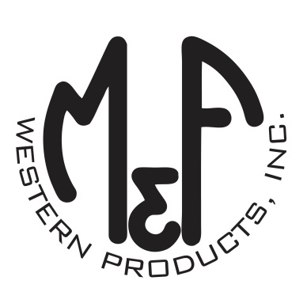

PRODUCT DESCRIPTION

**#9500014**

**Details**

* Western Moments Home Decor
* Wood Wall Sign
* Multi Colored
* Dimensions: 18-1/4” x 12-1/4” (With Hanger)
* Dimensions: 18-1/4” x 7” (Sign Only)
* USA Flag Motif
* “Pride of America” Wording
* Metal Words
* Hangs by Curly Wire

**Description**  
  
*Add a patriotic flair to your space with this USA flag wall hanging by M&F Western Products. The red, white and blue wall sign with the words “Pride of America” in metal letters will proudly hang on your wall with the curly metal wire hanger. Makes a great gift, or buy for yourself.*

