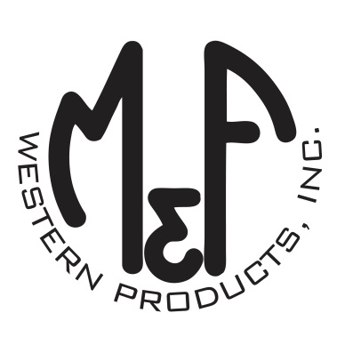

PRODUCT DESCRIPTION

**#9500005**

**Details**

* Western Moments Home Decor
* Metal Wall Hanging
* Silver/Black
* Dimensions: 10” x 13”
* Black Deer Design
* Hangs by Rope

**Description**  
  
*Add an authentic rustic feel to your home with this wall hanging by M&F Western Products. The metal sign has a black deer head on the top, and hangs on the wall with a rope. This wall hanging would make a great gift for that special hunter in your life.*

