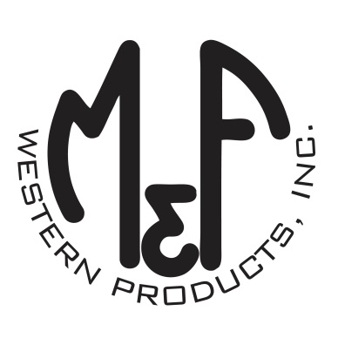
PRODUCT DESCRIPTION

#1518733
Details
- Ariat Youth Cap
- Turquoise
- One Size: Adjustable Snap Closure
- 6 Panels
- Medium High Profile, Structured
- Ariat Signature Logo on Front
- Purple Mesh Back
- Purple Contrast Stitching
- Embroidered Eyelets for Ventilation
- Matching Fabric Button Sewn on Top
- 7 Post Snap Closure
Description
Your little one will enjoy the cool style of this Ariat cap by M&F Western Products. The cap is turquoise with an Ariat signature logo embroidered on the front. There are embroidered eyelets and a fabric button on top, which gives this cap a classic look. The back is purple mesh and is adjustable at 7 positions to get that perfect fit.

