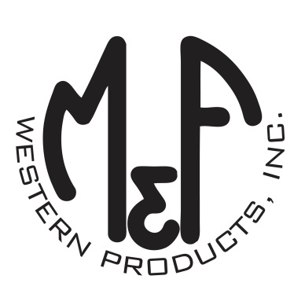

PRODUCT DESCRIPTION

**#1517903**

**Details**

* Ariat Youth Cap
* Navy
* One Size: Adjustable Snap Closure
* 6 Panels
* Medium High Profile, Structured
* White Ariat Signature Logo on Front
* White Pinstripe and Accent Stitching
* White Mesh Back
* Embroidered Eyelets for Ventilation
* Matching Fabric Button Sewn on Top
* 7 Post Snap Closure

**Description**  
  
*Your little one will enjoy the cool style of this Ariat cap by M&F Western Products. The cap is navy blue with white pinstripes, and has a white contrasting Ariat signature logo embroidered on the front. There are embroidered eyelets and a fabric button on top, which gives this cap a classic look. The back is white mesh and is adjustable at 7 positions to get that perfect fit.*

