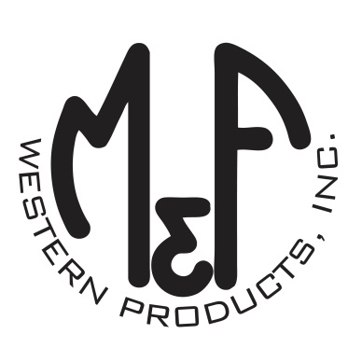

PRODUCT DESCRIPTION

**#1517833**

**Details**

* Ariat Youth Cap
* Heather Grey
* One Size: Adjustable Snap Closure
* 6 Panels
* Medium High Profile, Structured
* Turquoise Ariat Signature Logo on Front
* Turquoise Accent Stitching
* White Mesh Back
* Embroidered Eyelets for Ventilation
* Matching Fabric Button Sewn on Top
* 7 Post Snap Closure
* 100% Polyester

**Description**  
  
*Your little one will enjoy the cool style of this Ariat cap by M&F Western Products. The cap has a turquoise contrasting Ariat signature logo embroidered on the front, and embroidered eyelets on the top. The back is white mesh and is adjustable at 7 positions to get that perfect fit.*

