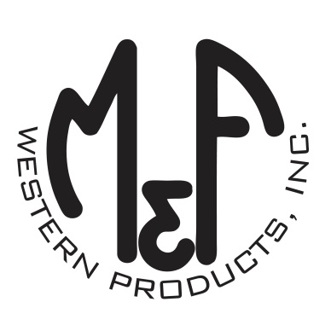
PRODUCT DESCRIPTION

#1515997
Details
- Ariat Ladies Cap
- Multi Colored
- One Size: Adjustable Snap Closure
- 6 Panels
- Medium High Profile, Structured
- Bright Color Serape Brim and Bill
- Ariat Signature Logo on the Front in Black
- White Mesh Back
- White Contrast Stitching
- Embroidered Eyelets for Ventilation
- Matching Fabric Button Sewn on Top
- 7 Post Snap Closure
- 100% Polyester Woven
Description
Ride your horse in western fashion with this Ariat cap by M&F Western Products. The cap has a multi colored serape brim and bill, and a black Ariat signature logo on the front. The back is white mesh and has a 7 post snap closure to get that perfect fit. You will love the quality and comfort of this beautiful cap.

